**James Rehak**

AIT 642 / COSC 603

Software Testing and Maintenance

Spring 2016

**Project #1 Task 3 – Reengineering Legacy Systems**

**Task 3 – Using Eclipse and Git / GitHub Desktop for Configuration Management.**

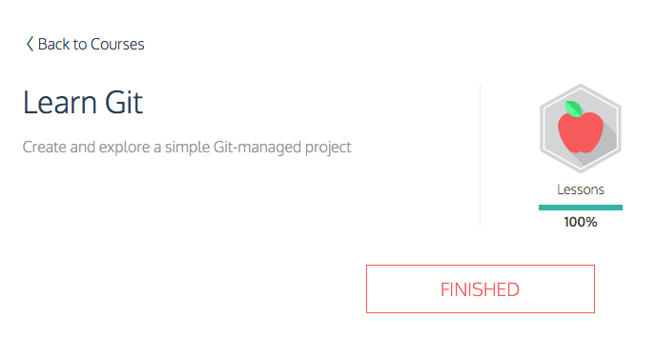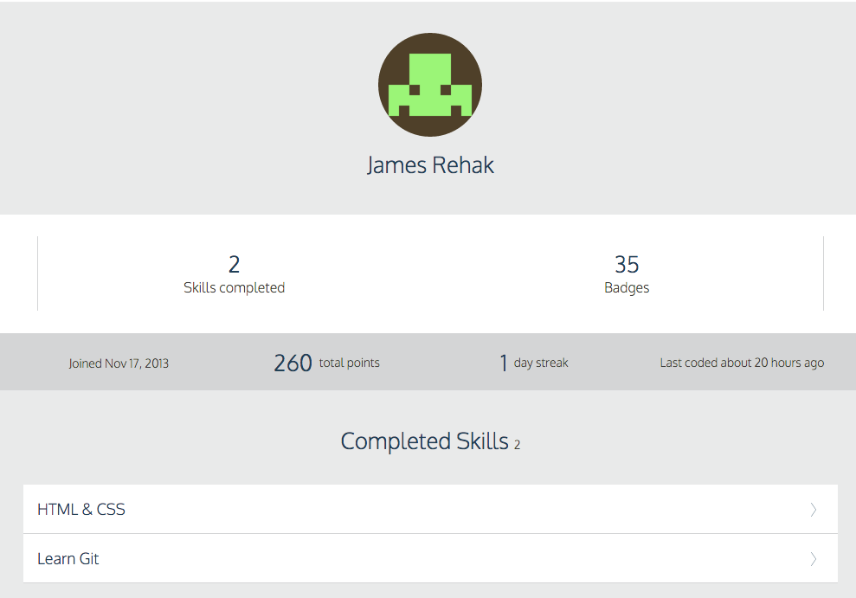

I found Codecademy to be extremely useful for learning the fundamentals of git. I knew about github before this course, but never used it. It would have been very helpful for my Database and Applied Cryptography group projects… Emailing source code is unbearable. Learning version control should be a mandatory subject before getting involved in group projects.

Github Desktop makes the workflow even easier, though it is causing me to forget all of the command line I learned in Codecademy. I noticed Eclipse has git control tools build into it. This has been very helpful for getting my beater computer working with the project because OS X 10.7 is too old to run Github Desktop. It would seem supporting a legacy system had low business value and therefore was not done.